[](https://www.google.com/url?sa=i&rct=j&q=&esrc=s&source=images&cd=&cad=rja&uact=8&ved=0ahUKEwiA-qCcneTKAhVC4CYKHfFWCYsQjRwIBw&url=https://www.thefranchiseking.com/franchise-owners-making-money&bvm=bv.113370389,d.cGc&psig=AFQjCNHVY4RGePj9Gk5Z4W7XbBsrO0QhWw&ust=1454882764921321)Win Big Bucks

at BHS Booster’s

Bingo Night!

When: Saturday, March 5, 6:15-10:30 p.m.

**First game begins 6:30 p.m. Free admission!**

Where: Fire Barn, 218 S. Main St., Bartlett

What: Bingo – $1 per card or $5 for 6 cards

**New cards each game!**

• Bingo (Must be 18 to play) •

• 50/50 raffle • Cash Bar •

**[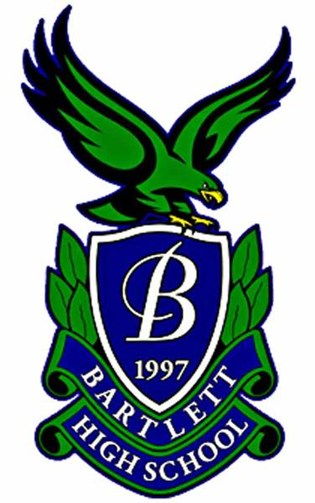](http://www.a-agames.com/bartlett-hs-booster-club/)Open to all; community support**

**welcome and encouraged!**

All proceeds will benefit the Bartlett High School Booster Club, an

Illinois Not-For-Profit Corporation. The Club is an organization of parents, teachers, administrators, and community members who serve as a support organizationfor all Individual Activity Groups encompassing academic, athletic, fine arts and all other extracurricular activities at Bartlett High School.

**For information, contact treasurer@bhsboosters.org**