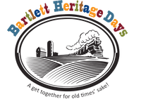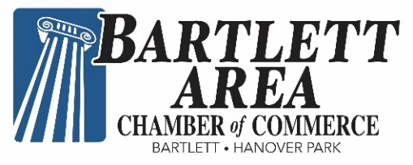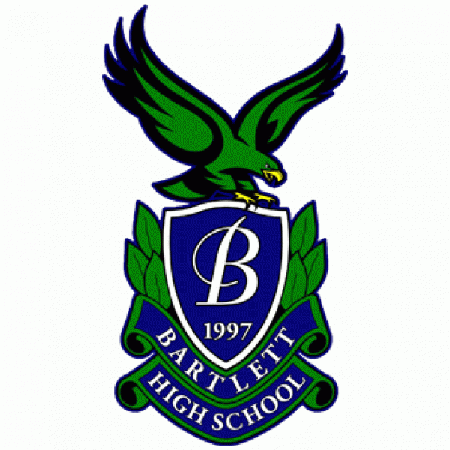

BINGO is BACK in Bartlett!

Please support the Chamber - BHS Booster Club partnership in the BINGO Tent

at Bartlett’s Heritage Days!!

When: Saturday, September 10, Noon – 6 p.m.

Sunday, September 11, Noon – 5 p.m.

Where: Banbury Fair, 211 W Railroad Ave, Bartlett

What: Bingo - $1 per card or $5 for 6 cards

New cards each game!

* BINGO (Must be 18 to play) ● Cash Bar

**Open to all – Community support welcome and encouraged!**

Proceeds will benefit Chamber of Commerce programs, services and scholarship and the Bartlett High School Booster Club’s academic, athletic, fine arts and extracurricular activities. For information, contact [Mary@bartlettareachamber.com](mailto:Mary@bartlettareachamber.com) or [treasurer@bhsboosters.org](mailto:treasurer@bhsboosters.org).

